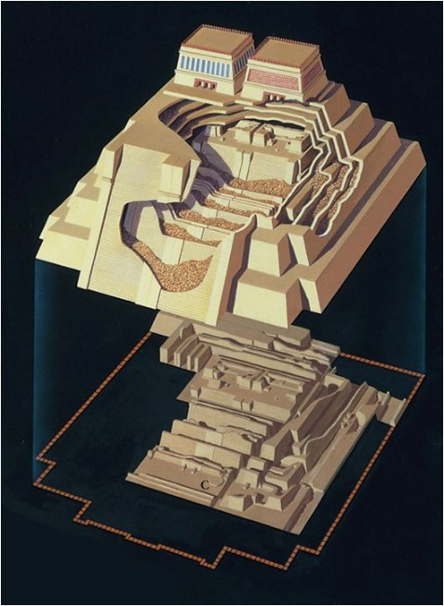Aztec Temple Level Design

The picture on the right is Temple Mayor. This temple was one of the Aztecs main temples in the city of ‘Tenochtitlan’. I chose this temple because of the structure, the two shrines at the top and how each room gets nested into the ground, layer by layer. By using this image as reference, the design started by making the first room, the first shrine.   
  
While researching Temple Mayor’s shrines, I came across the following sentence; “One was dedicated to Tlaloc, the god of water on the left side (as you face the structure), and one to Huitzilopochtli, deity of war and of the sun, on the right”.

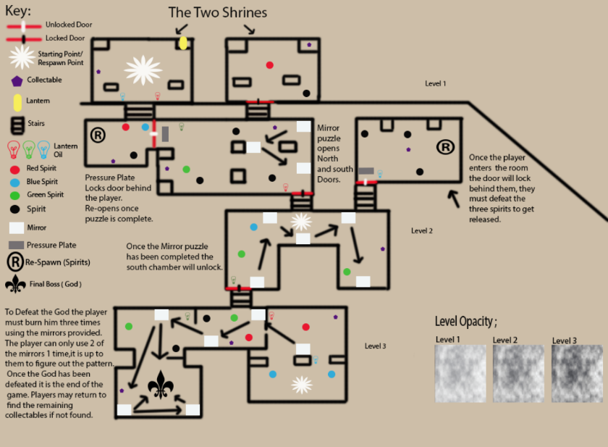The player will start in the left shrine where the room is quite light. This will be the tutorial level, the player must find the lantern located on right side of the room, it will be sat on a large stone with ‘Tlaloc’ engraved into it. The lantern will automatically be equipped to the player so they can see a normal flame in front of them (this will also help their current vision). There are two oil lanterns on the left and right side of the exit, one oil lantern is red, the other is blue. Each enemy has its own light colour, there will be two enemies sat at the exit by the stair case, one will be red, one will be blue. Once the player interacts with the oil lanterns they will see the flame change colour (depending on which colour they choose). If for example the player chose blue; the blue spirit (enemy) will slowly start to back away, if the player chose the red, the red spirit would start to back away instead. This introduces the player to one of the core game mechanics, keep the spirits at a distance. As a group we wanted the players to learn how to play the game without us directly telling them what to do and where to go, so we have used colours to guide the player through. Once the player exits the tutorial room and enters darkness, the lantern will start to deplete. While the player is in the dark their life is at risk so they need to keep the lantern lit throughout the whole game. If the player is in the darkness without a lit lantern their health will start depleting (in the first room we will give the player extra time so they will not be punished for moving forward).   
  
There will be 10 collectibles to find throughout the three levels, this is for our target audience achievers and explorers, this will let the player choose their own path so they can find the hidden artefacts. Tutorial level has one collectible, level one has three collectibles, the second shrine has one collectible, level two has one in the main room and another in the hidden north chamber. (the chamber collectible acts as a player reward). In the third level there will be three collectibles to find.

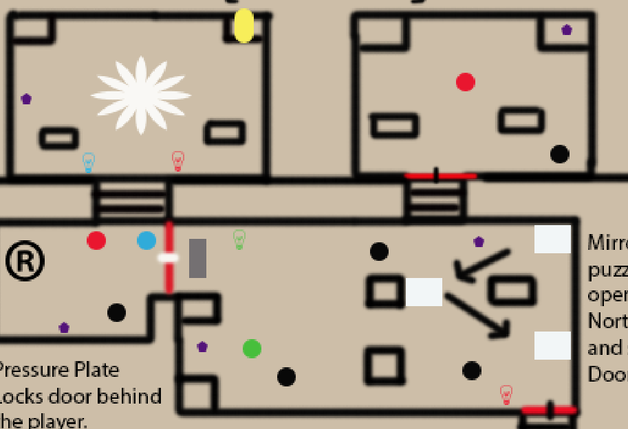The first level begins once the player enters the room, they will activate a hidden pressure plate which make the door close behind them. The player is now trapped in the room until the puzzle is complete. The player will come across three mirrors once they approach the middle of the room, these are used as another core mechanic. Light from the lantern must reflect off one mirror to the other for the puzzle to be complete and unlock the door. if the player stands at a certain angle they should be able to hit all three at once however, the spirits in the room will be approaching the player constantly, so they must be aware of their surroundings. They will stand in the way of the mirror and move around the room making it harder for the player to focus.

(the first level’s darkness will be low so the player can see where the mirrors are and the spirits won’t harm the player unless they run out of light).

Once the reflective mirror puzzle has been completed the north chamber will then open. This is the second shrine ‘Huitzilopochtli’s shrine of war and sun’, this shrine will be quite light as the player is traveling back up the stair case. This room was made for exploration as there is a hidden artefact in the room but the player is also alone with a red spirit. The oil lantern is in the first level room next to the south door. This has been placed on purpose so the player can see they have opened a second door by completing the puzzle. This now gives the player a choice (do they want to go back up to the shrine and collect that missing artefact? Or would they like to see what’s been hidden behind this door?).

Going down to the next level increases the mist / darkness, the player will now only see the outlines of objects and spirits until they are closer, the mirrors will still be noticeable as the light will shine off them creating a white glow. The light from the oil lamps will now start to deplete faster, so they player must focus on keeping the light lit.

This is where the next respawn point will be, if the player dies they will respawn here. This will not anger the player if they know they can respawn at a closer point, if they had to start from the beginning this would lead to frustration and will probably make them leave the game completely, it won’t give them the strive to try again as they will think all their progress has been lost.

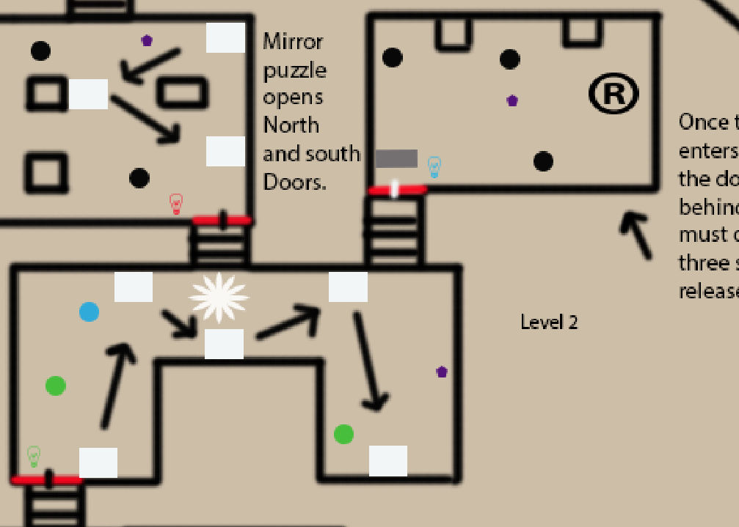

Level two has a more complex mirror puzzle, the room is in a n shape, the player must start in the left room and reflect the light so it bounces from the first mirror to the second mirror which is located at the top of the room, the light must be able to reach the third mirror to reach the next mirror on the left, if it doesn’t reach it will not hit the final mirror on the right side. Once the mirror puzzle is complete the south chamber door will open however, there is a little twist. When the player starts the level, they will be approached by a blue spirit (slowly so they have time to get away from it). The last time they saw a blue spirit was in the first room, they have the choice to go to the start but the lantern will burn out by the time they make it back. There is another blue oil lantern in a secret room on the right side, if the player enters this room to look for the blue oil lantern they will stand on a pressure plate and lock them in the room with three original spirits. This room will have a beam of sunlight from the broken roof outside the temple, this beam will keep the player alive if their lantern runs out (safe zone). The player must use the blue oil lantern stand to re-light their lantern so they three spirits back away and disappear, the player gets rewarded with a missing collectable and the door will be unlocked for them, they now have access to the blue oil lantern to ward off the blue spirits.

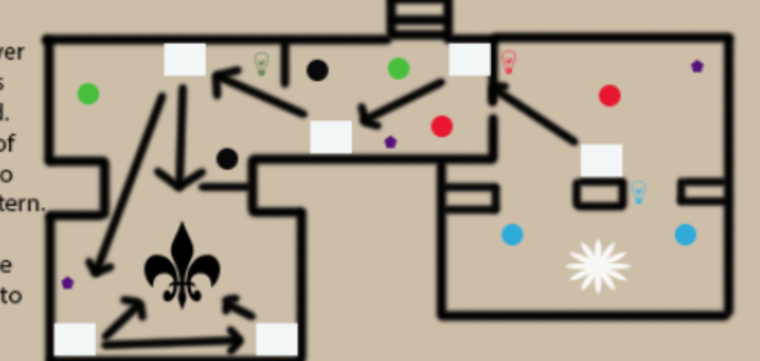The final room can be entered by the south chamber stair way, where the room has gone pitch black and all the player can see is the lantern in front of them. This level will be more complex than the other two as the player will now feel like they know how to use the lanterns to solve the mirror puzzles but they going to put their knowledge to the test (they know what colours match the spirits, they know they must look for a mirror combination and reflect the mirrors to unlock a new area). The final boss (God) will be hidden on the left side of the room in his chamber of rest. The player will want to approach this side of the room as the god will make unusual sounds which the player hasn’t heard before. (a low growl or a snigger). On the right side of the room there will be another respawn point but the player will have to enter the room for it to be triggered. Red, Blue and green spirits will be used in this level so the player must keep switching colours while working out the mirror combination.

To defeat the boss the player must burn him with the mirrors provided in the room. There is a total of six mirrors in three open rooms. (one big room, just have three columns in the way). The boss needs to be burnt three times for him to de-spawn.

The god will respawn original spirits constantly until the player has burn him once.

To burn him once the player must find the starting mirror on the right side of the room once the player has reflected the light from the first to the second, third and fourth it should be easy to hit him straight on. To hit him the second time the player must move to the third mirror near the stairs, if they reflect the light from this mirror to the fourth at an angle they should be able to reach the fifth located behind the boss on the left side. Once the player has been hit the second time he will start to respawn the green spirits making it more complex for the player as they now need to avoid the spirits whilst reflecting beams. To hit the boss for a third time the player must use mirror four to reflect to the fifth and bounce to hit the final sixth mirror located at the back of the boss on the right side. Once the player has solved the puzzle and defeated the boss they will get rewarded with release (they can leave the temple and be free of darkness). The player then has a choice to go back into the temple to retrieve the missing artefacts the left-over spirits will still be roaming and they will need to use their lanterns wisely.

References;

Aztec temple Mayor. (n.d.). [image] Available at: https://i.pinimg.com/736x/8f/4b/0d/8f4b0dda58911ac6a998f6b4a878b7f6--indigenous-art-scale-model.jpg [Accessed 17 Oct. 2017].

Mist Image used for opacity. (n.d.). [image] Available at: https://img00.deviantart.net/09f3/i/2005/123/a/5/cloud__mist_texture_by_lish_stock.jpg [Accessed 17 Oct. 2017].

En.wikipedia.org. (n.d.). Templo Mayor. [online] Available at: https://en.wikipedia.org/wiki/Templo_Mayor [Accessed 17 Oct. 2017].